Assignment 4

Exercise 2.1

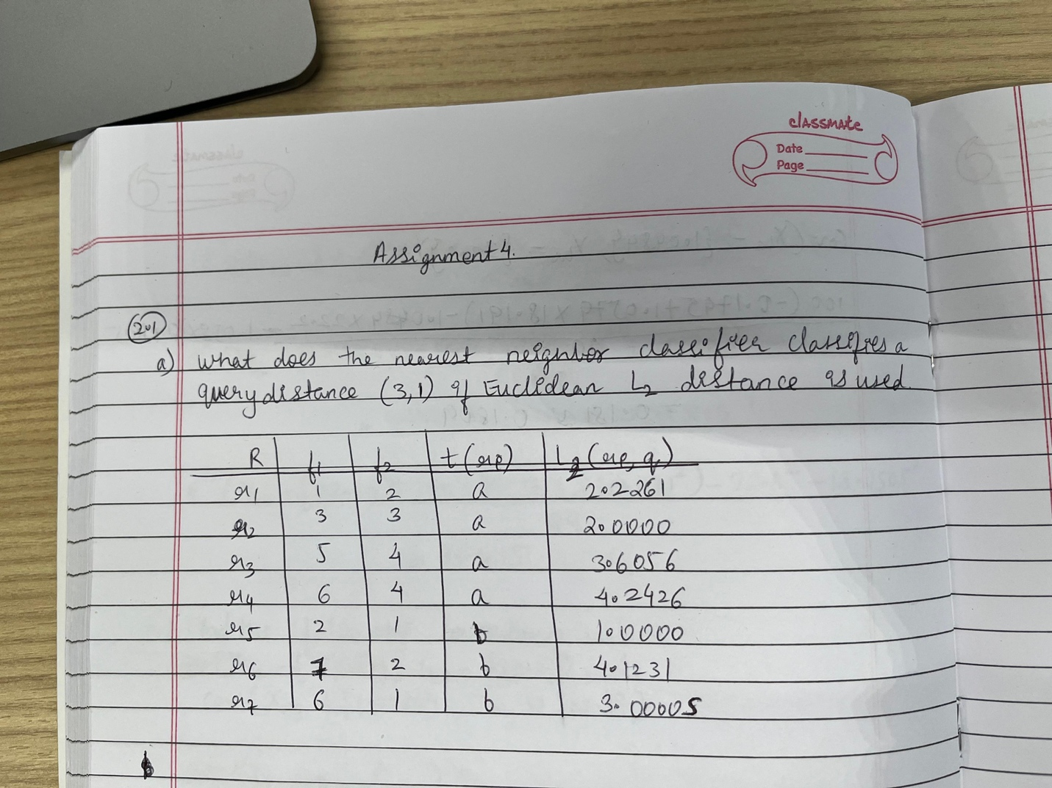

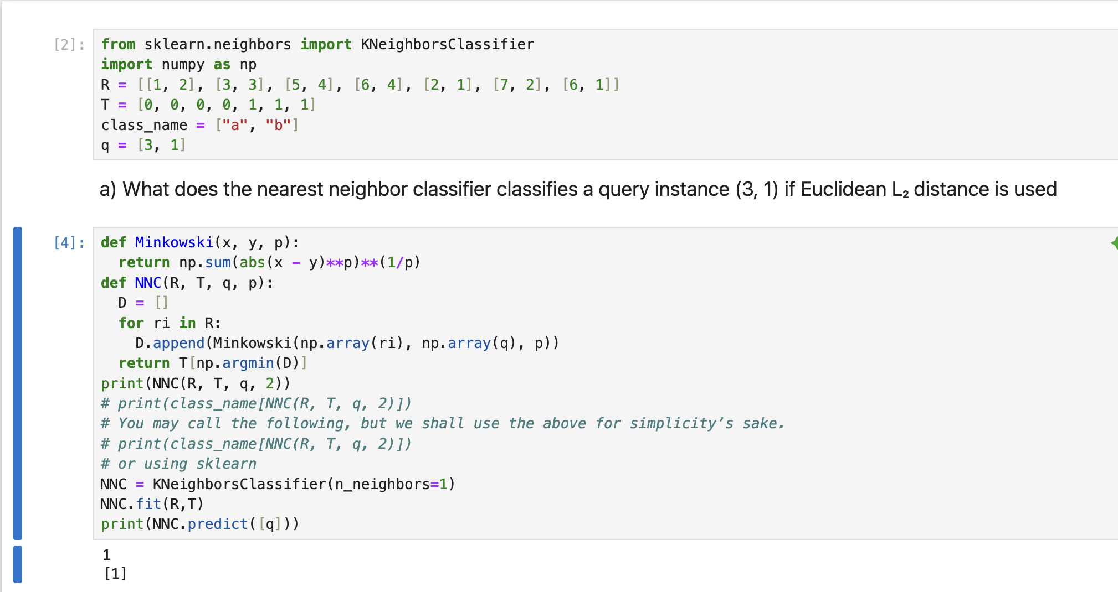

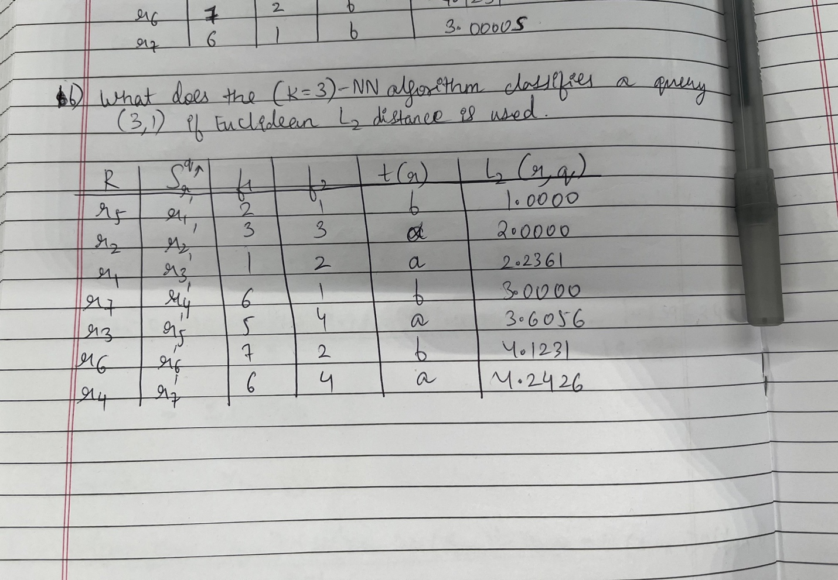

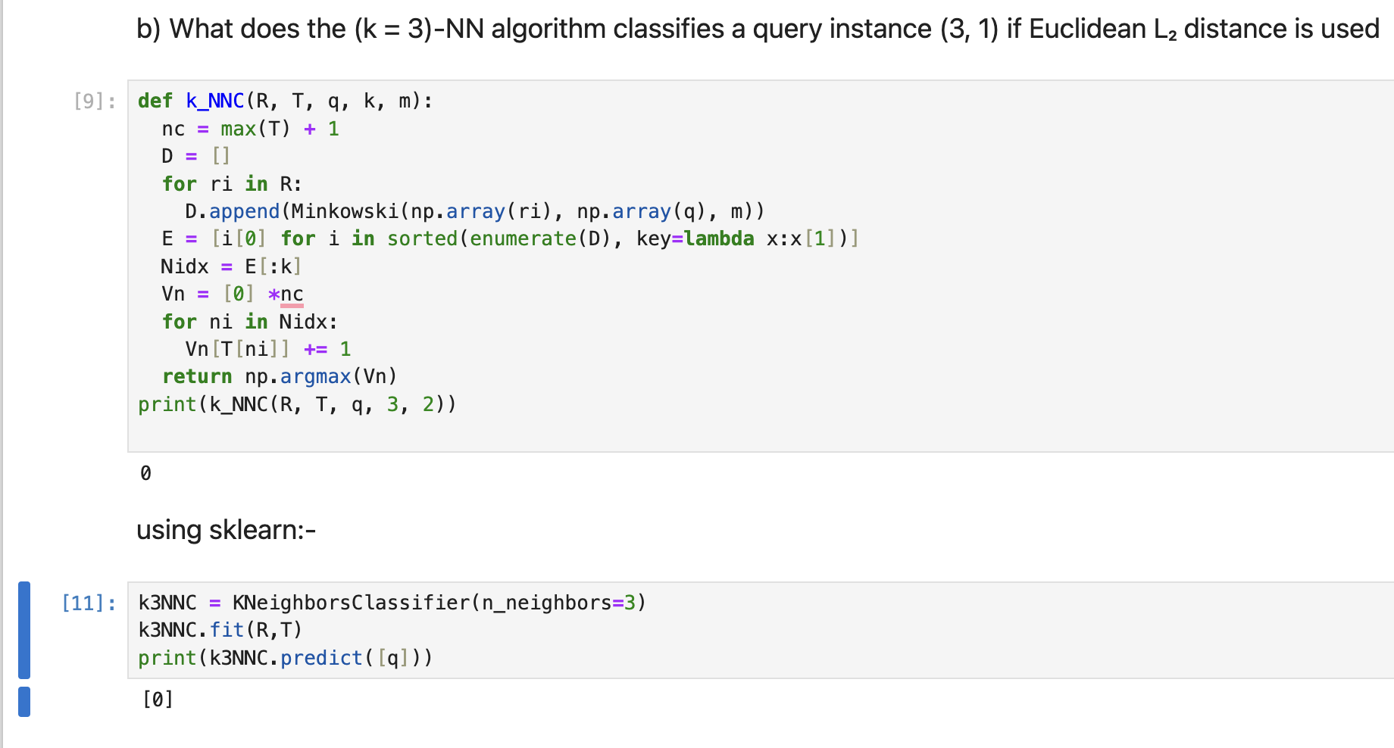

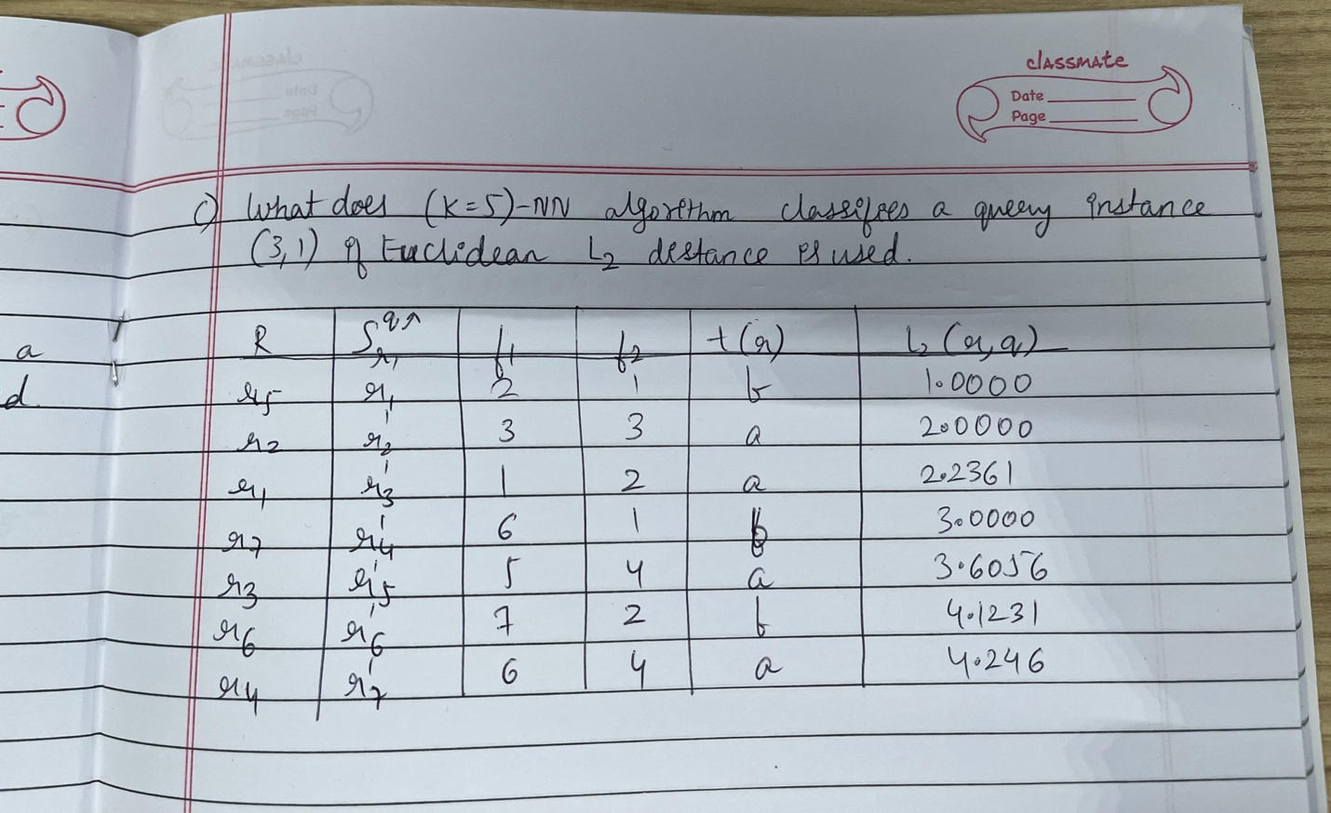

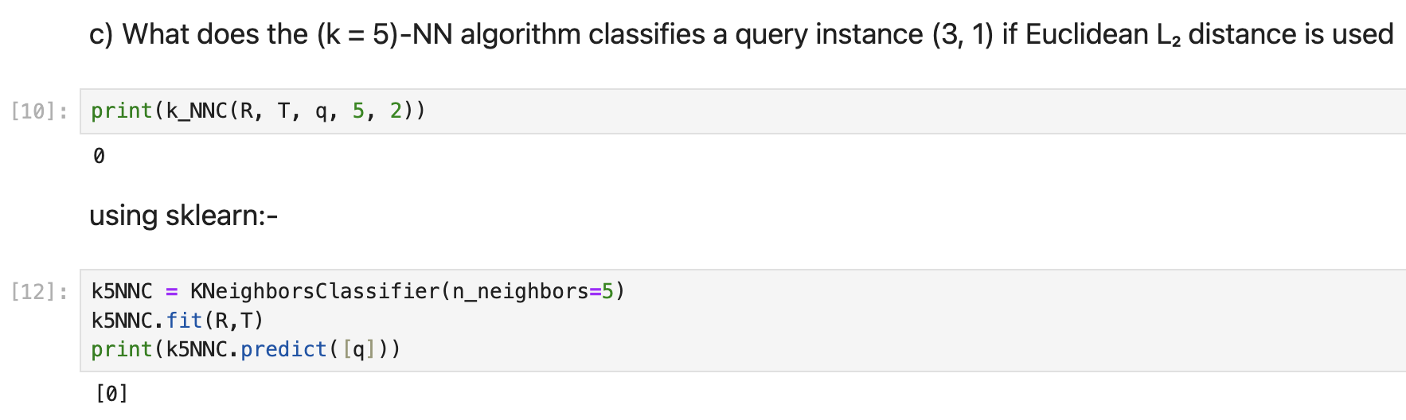

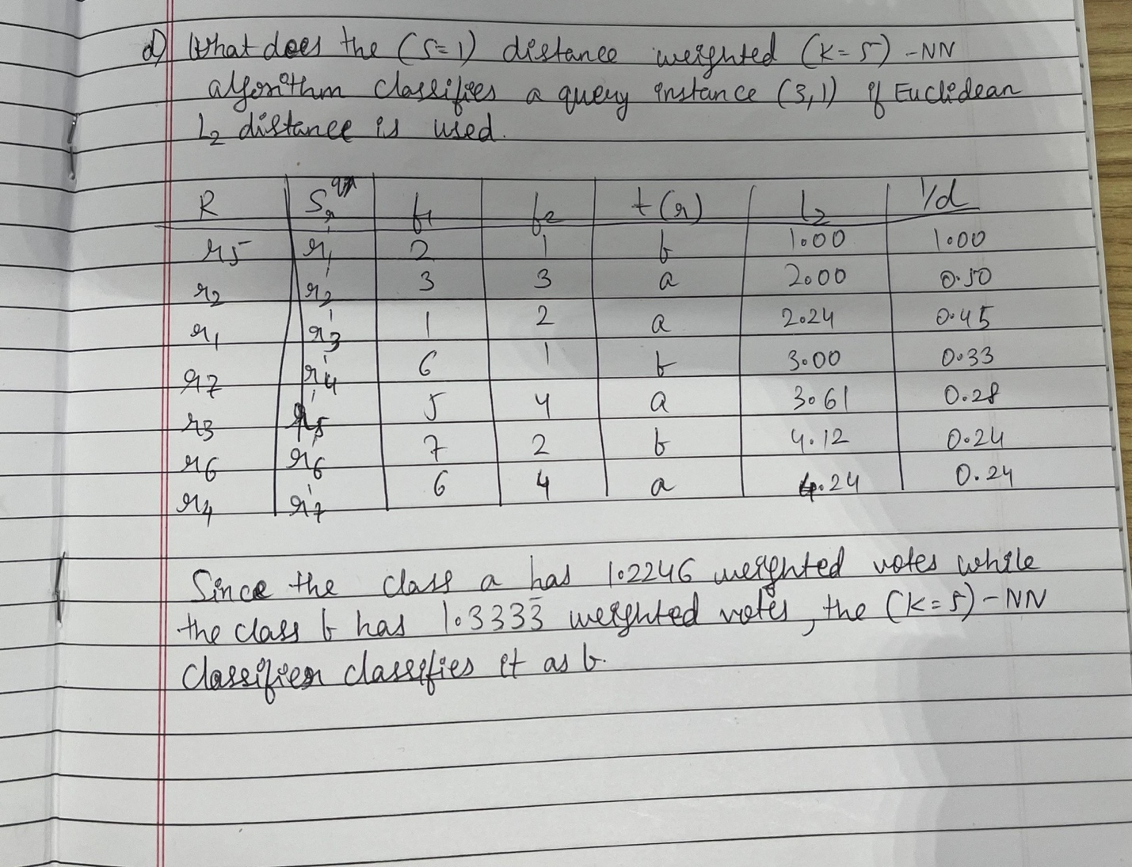

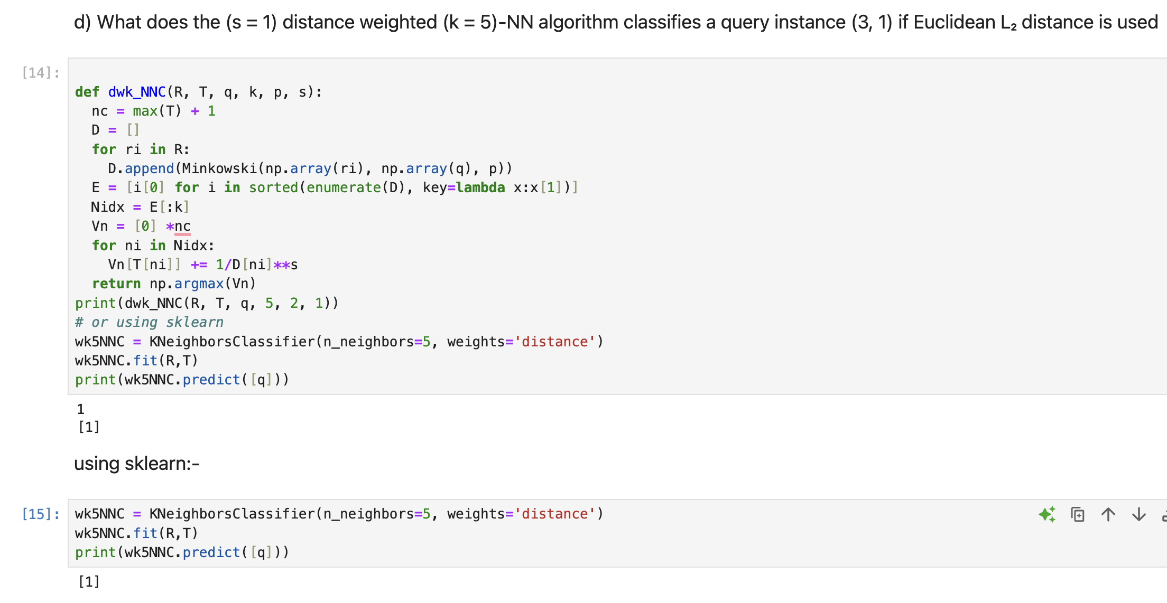

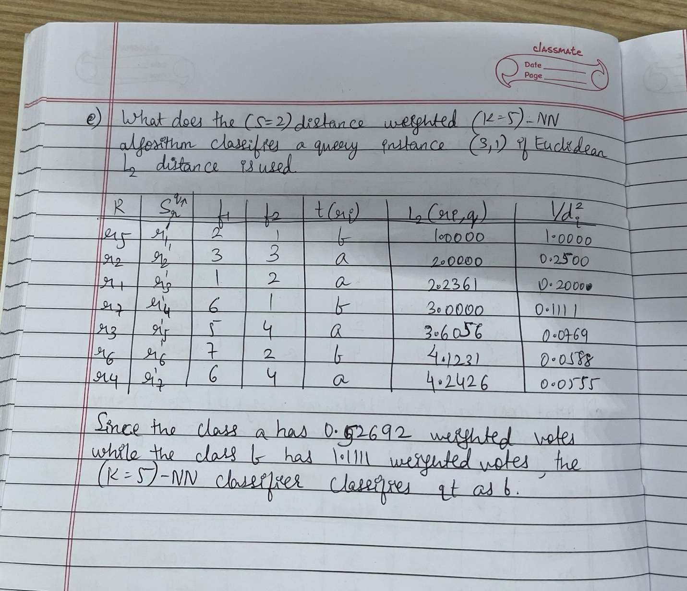

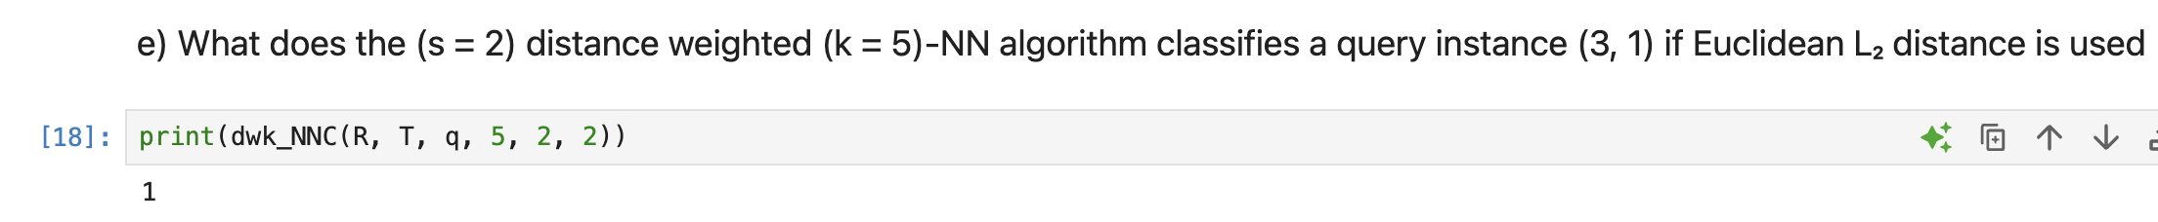

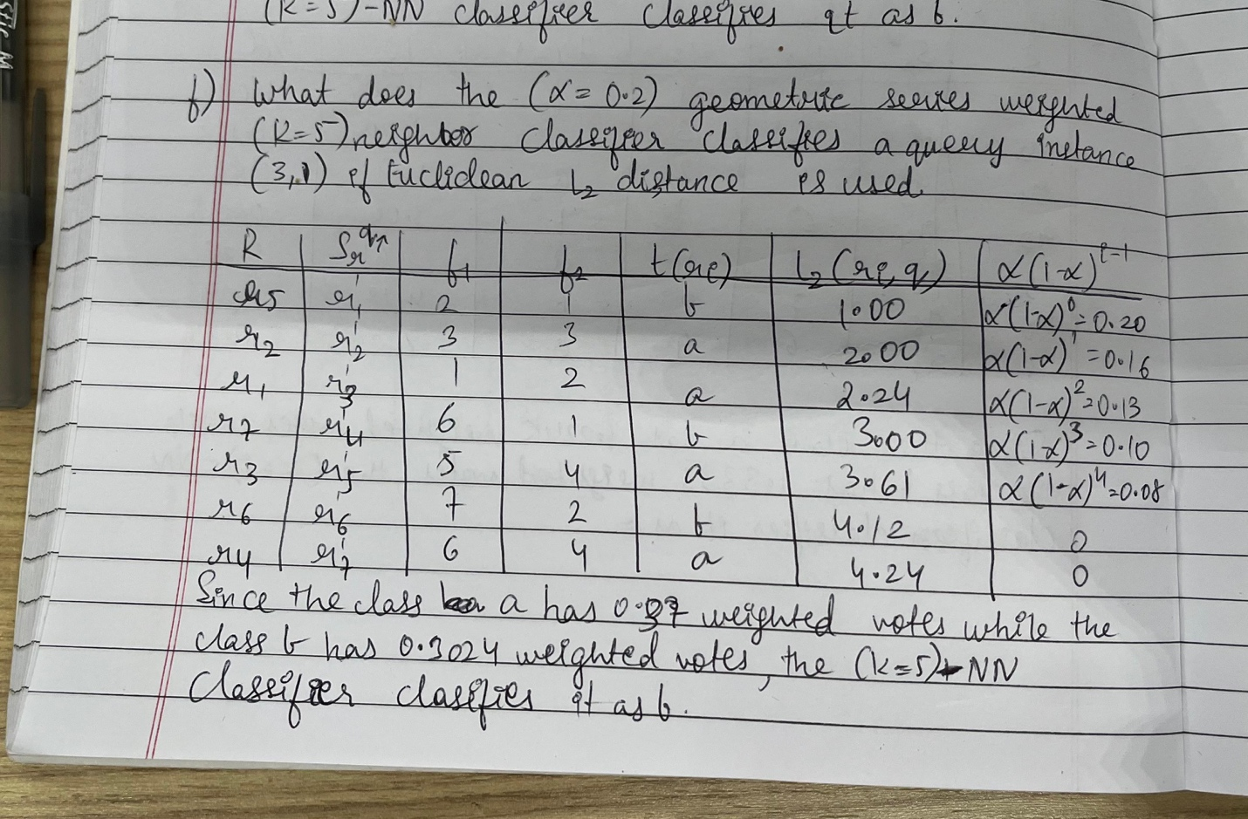

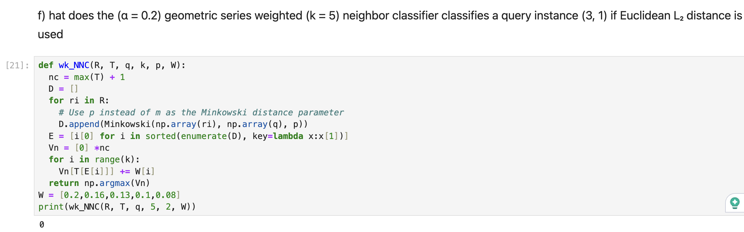

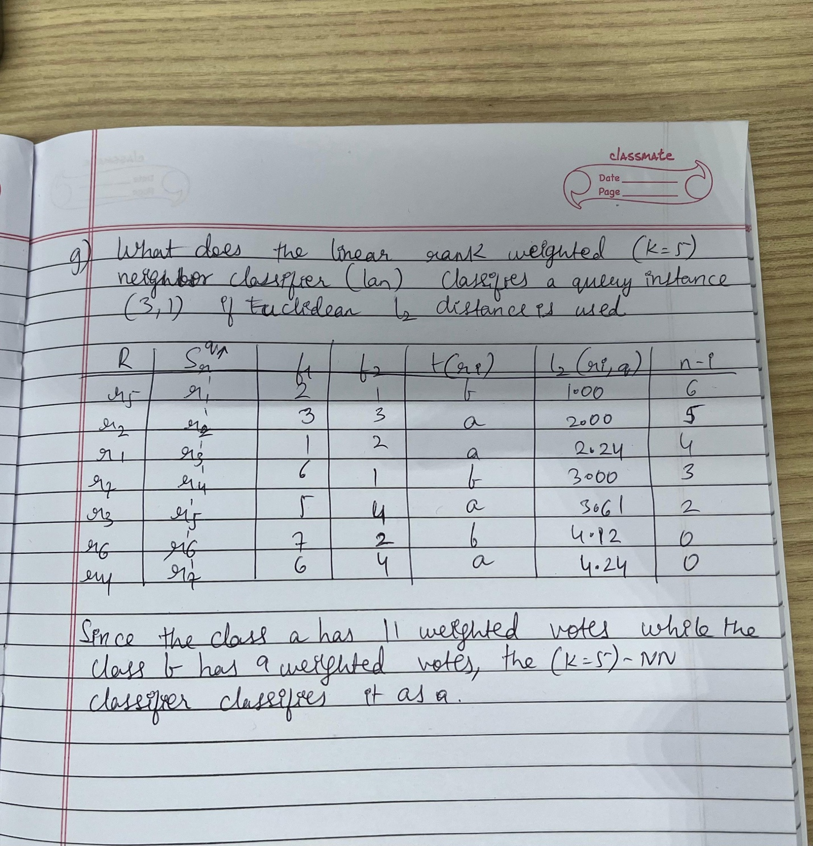

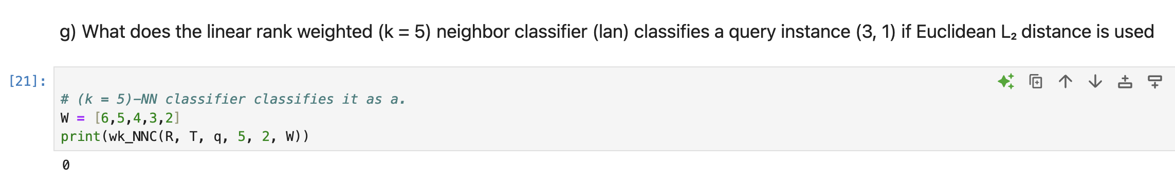

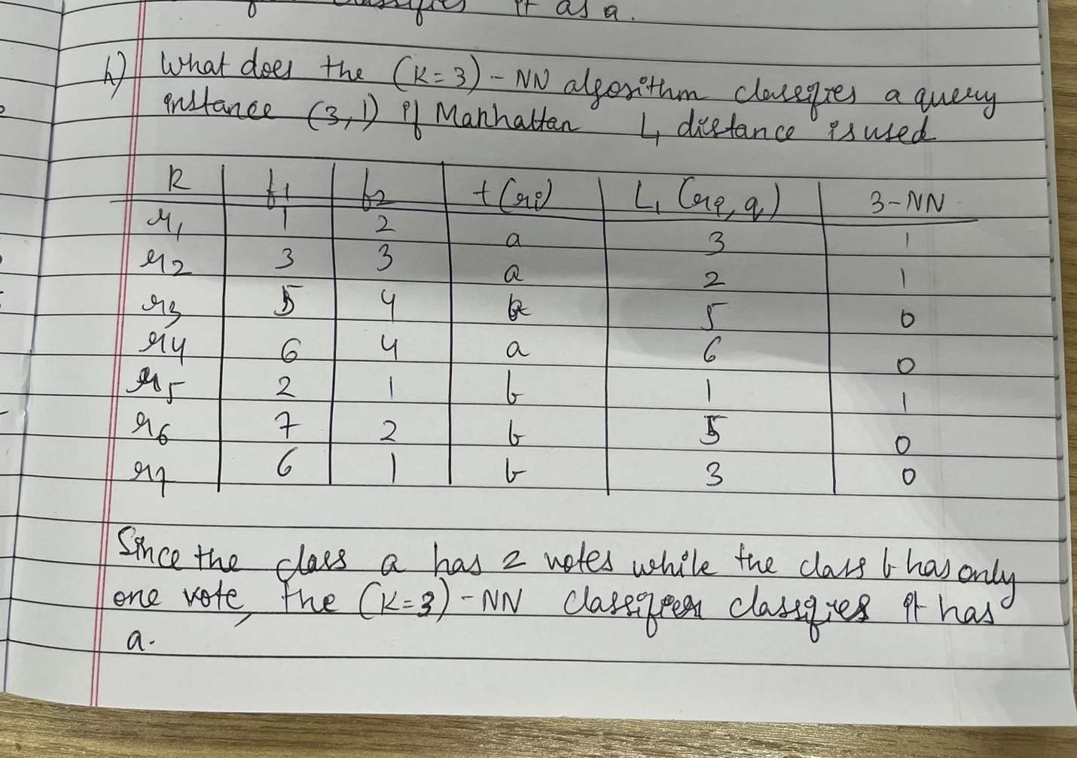

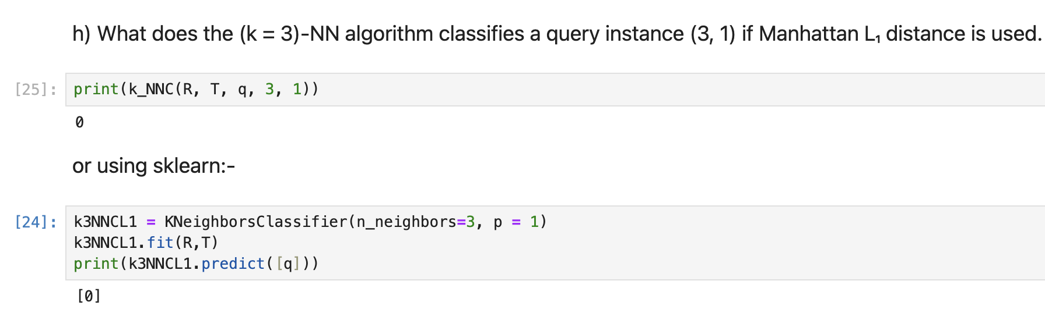

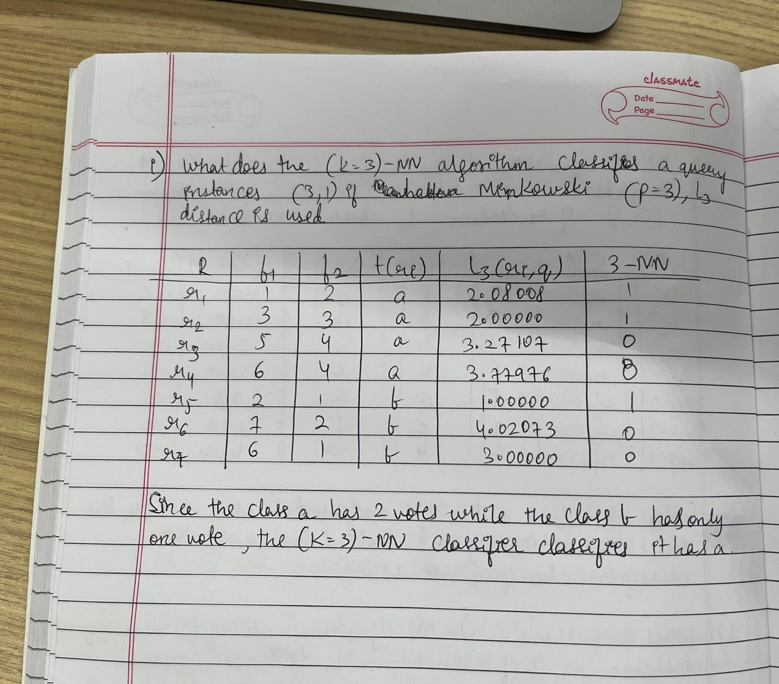

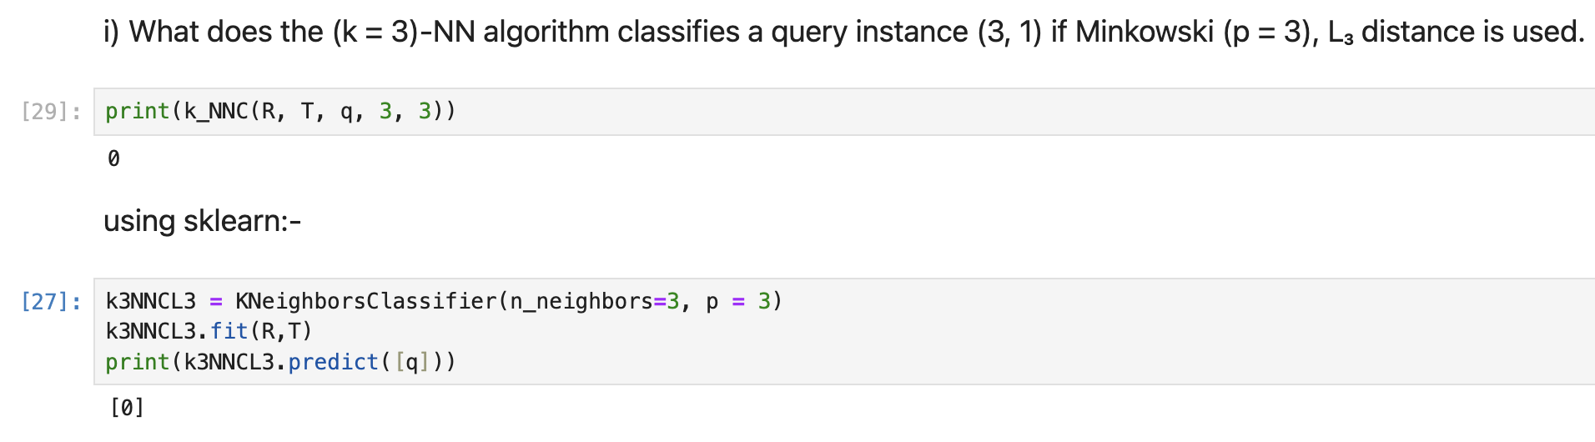

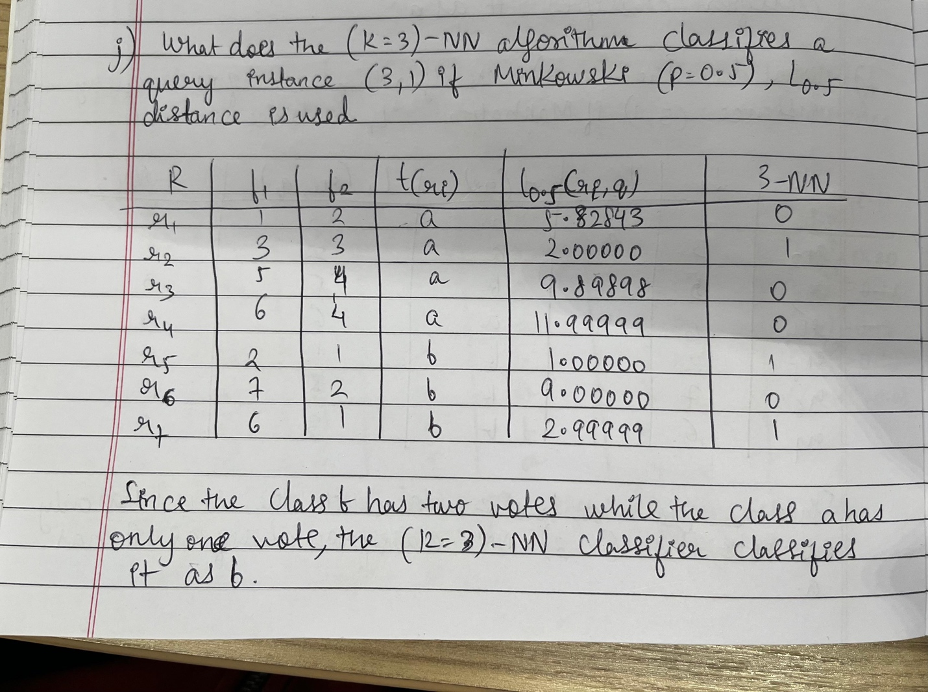

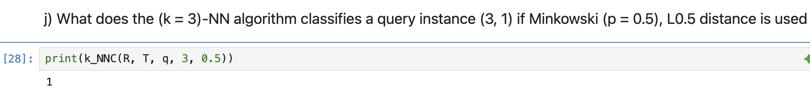

Exercise 2.7

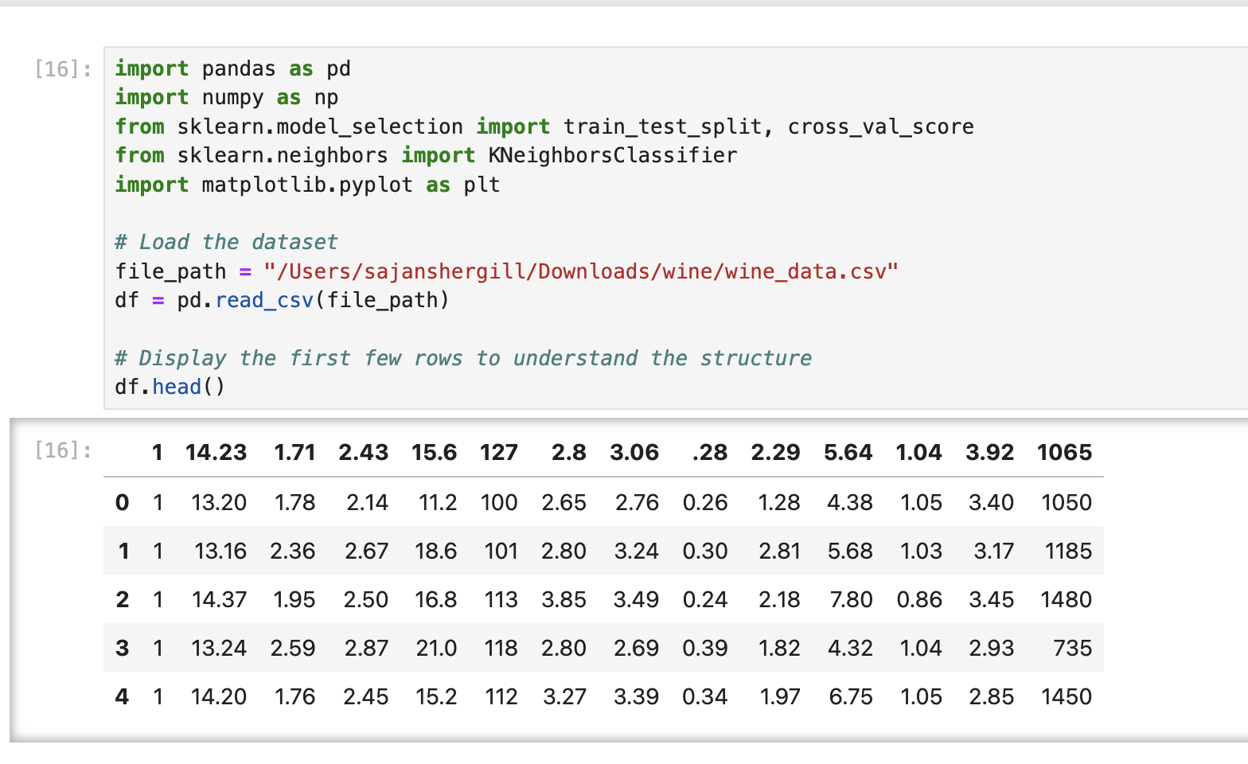

1. Find the optimal p value of Minkowski Lp for the nearest neighbor classifier. Try p = 0.5 ∼ 2.5 incremented by 0.1

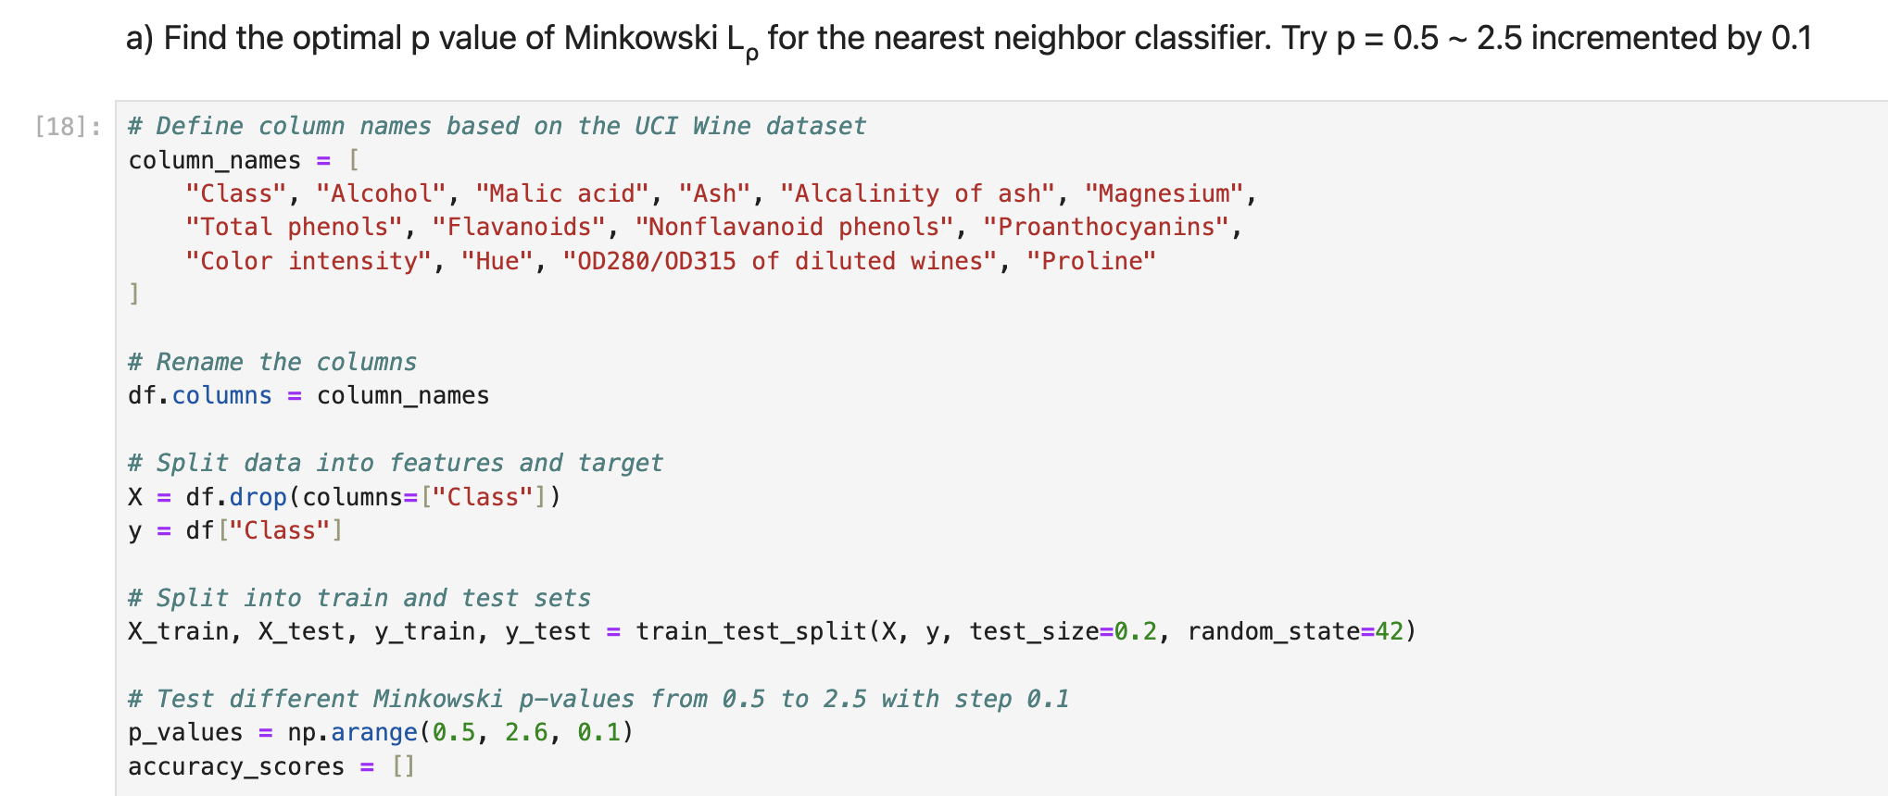

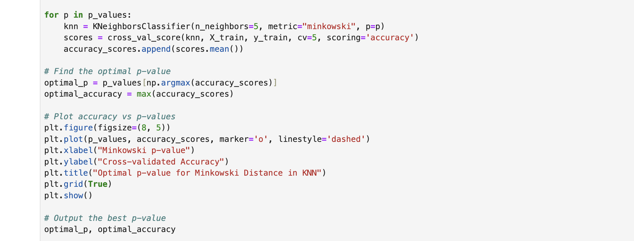

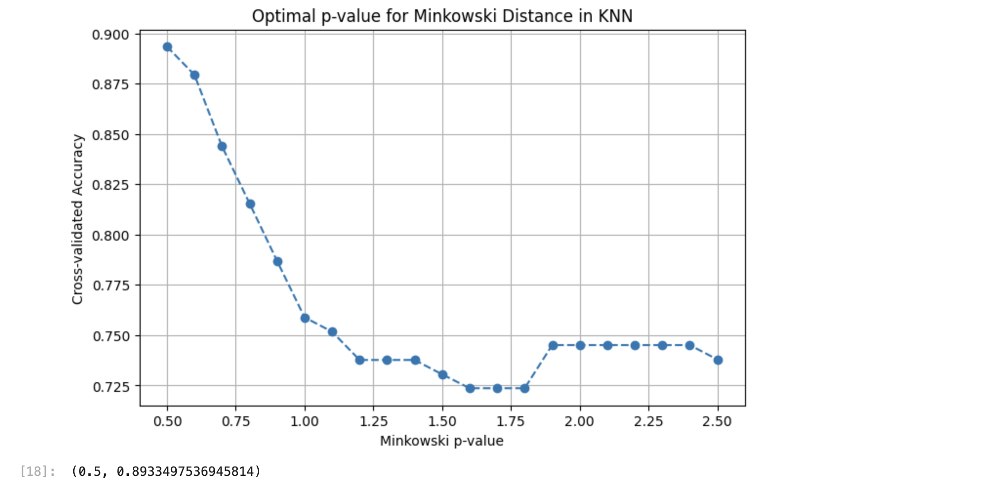

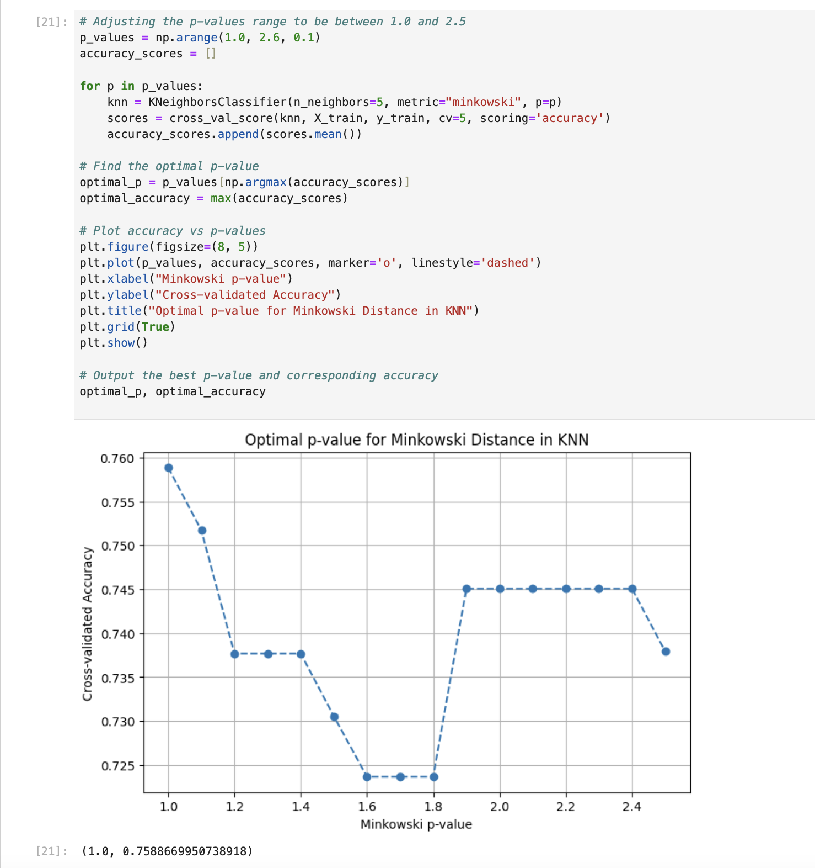

1. Find the optimal k of the kNN classifier. Use L₂

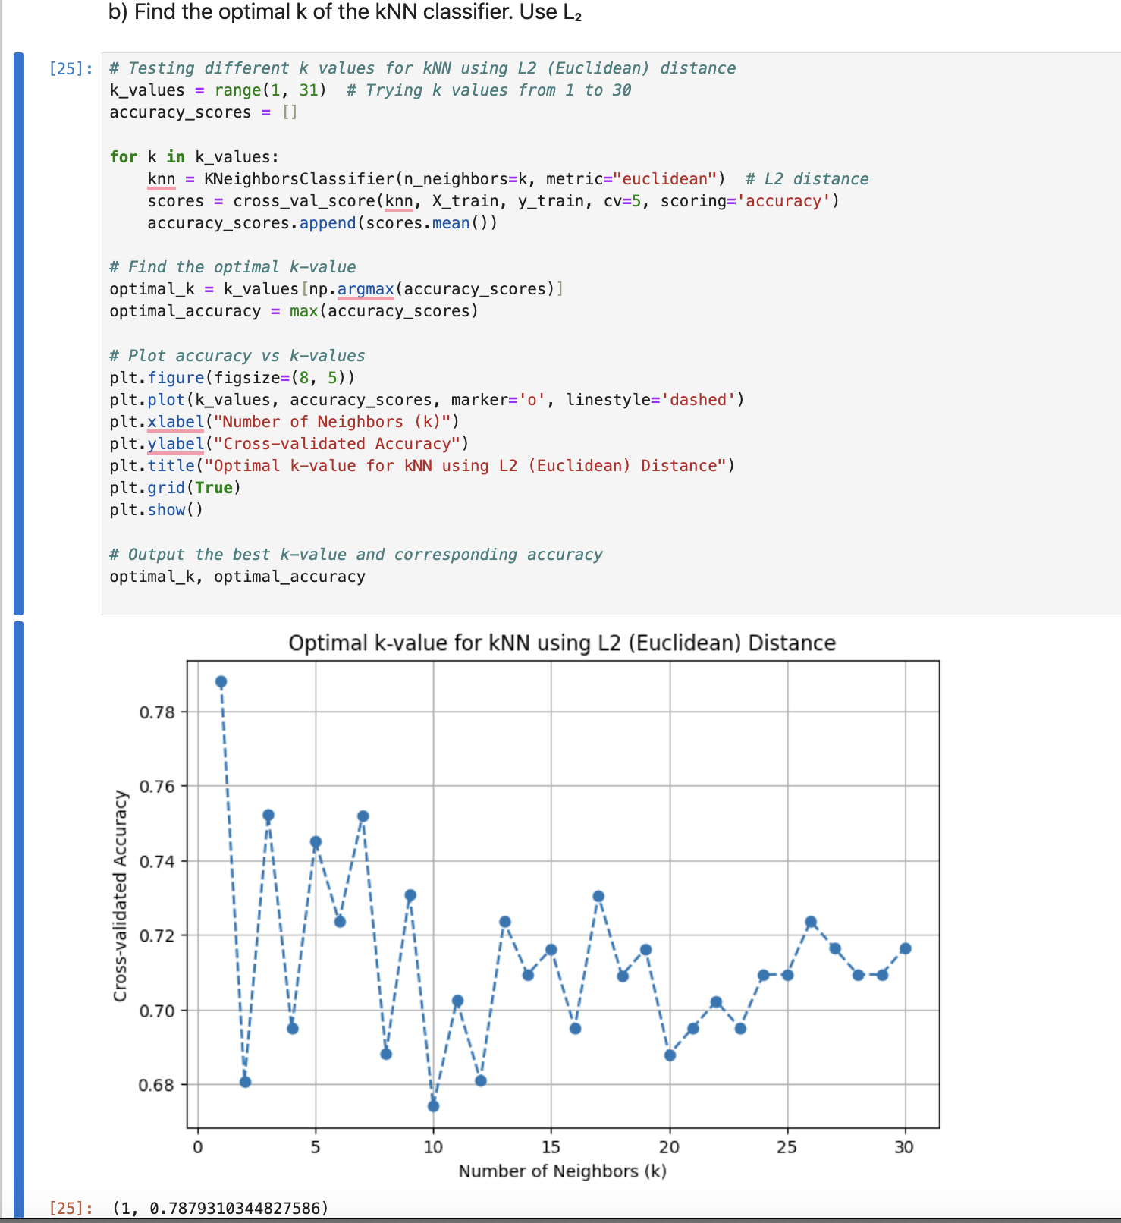

1. Find the optimal p-value for the distance wi = 1/d(rᵢ, q)p weighted (k = 5)-NN classifier. Try at least p = 0.5, 1, 1.5, 2, 2.5. Use L₂.

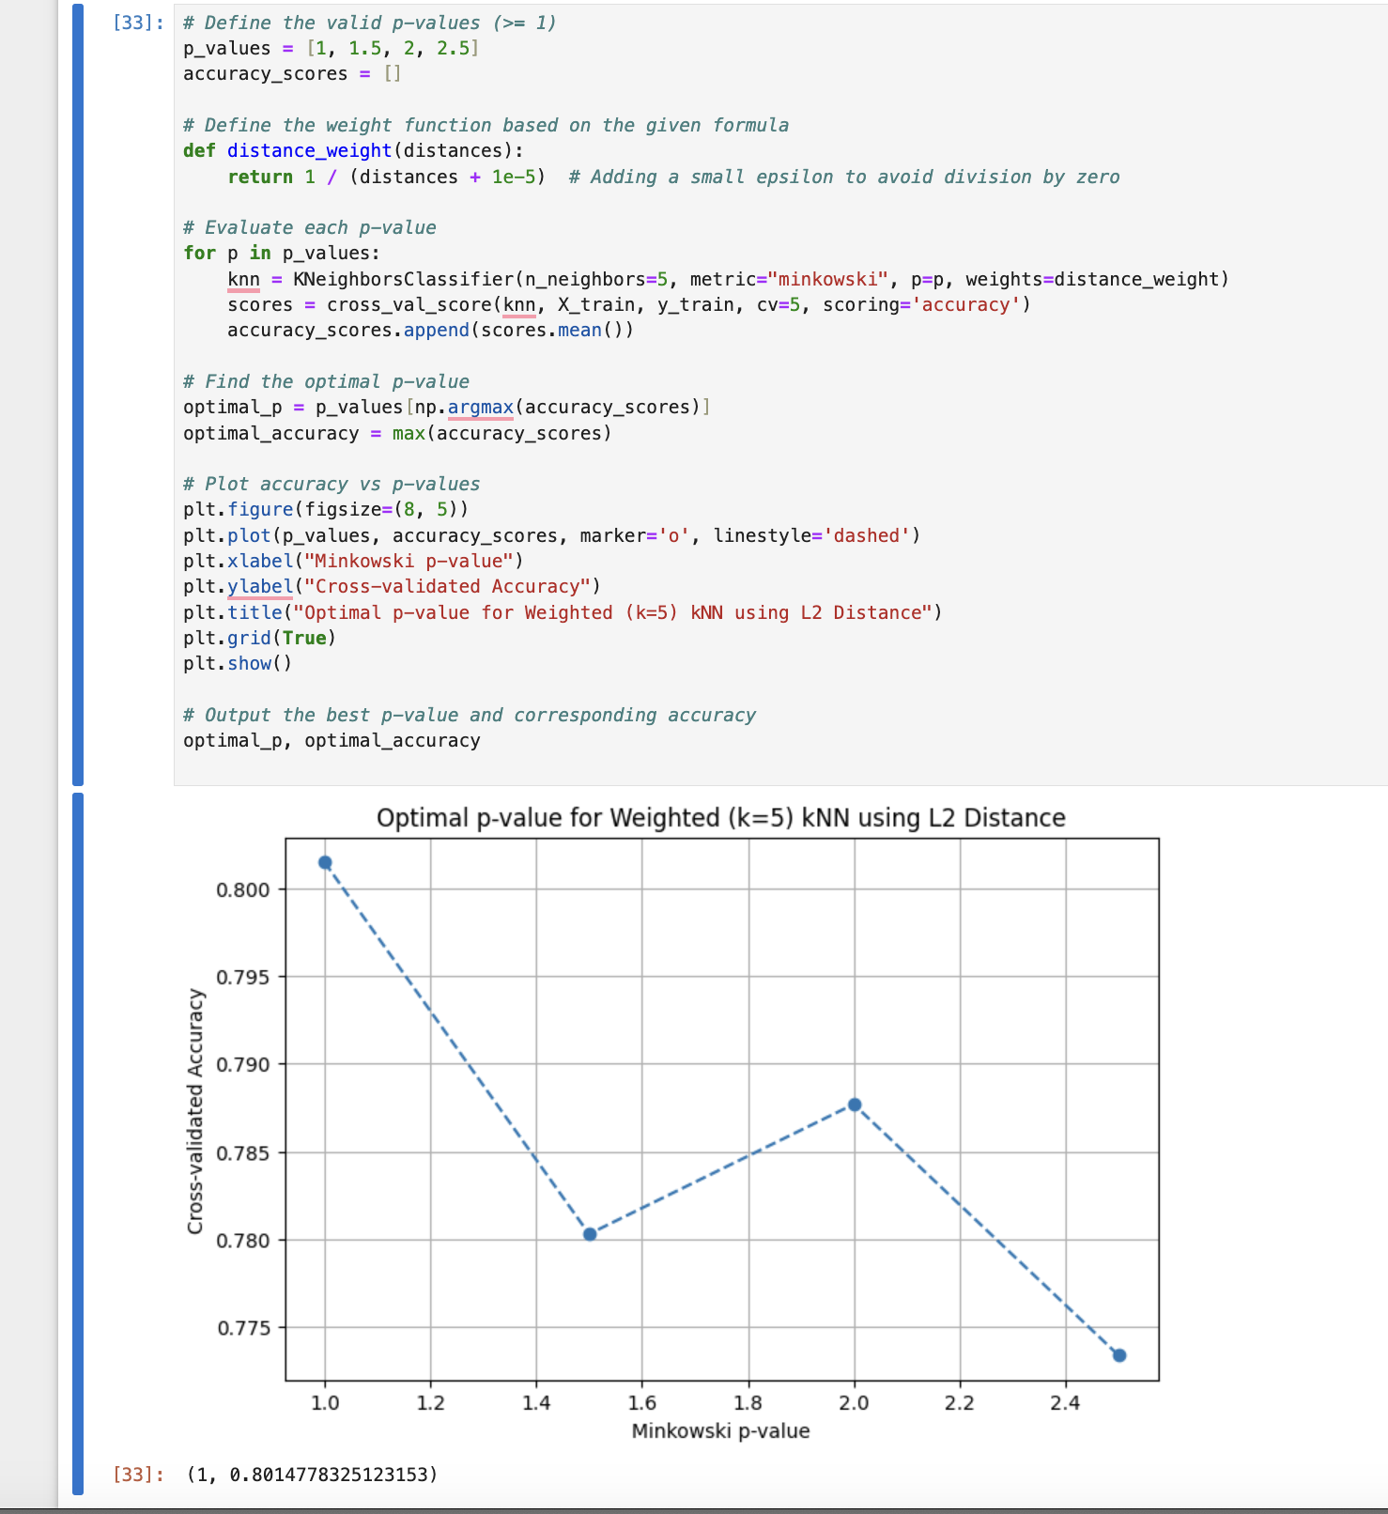

1. Discuss the result of the above experiments:

Insights and Takeaways:-

1. Manhattan Distance (p=1) is the Best Choice:

-Across all experiments, p=1 consistently gave the highest accuracy and lowest error rate.

This suggests that the dataset’s feature distribution makes absolute differences more meaningful than squared differences (Euclidean distance).

2. Low k-values Perform Better:

- The best k-value was 1 (1-NN), meaning each wine instance is classified best using its closest match.

Higher k-values reduced accuracy, possibly due to the inclusion of less relevant neighbors.

Weighted k-NN Shows a Slight Improvement

- When weights were applied, accuracy slightly improved to 80.15%, showing that closer neighbors should have higher influence.

3. Minkowski Distance Flexibility:

- Even though we experimented with different p-values, the dataset naturally favors a simpler L1 (Manhattan) distance.

Higher p-values (approaching Euclidean and beyond) didn't improve classification.